**Smart City Project - A Complete City Guide Using Database**

**ABSTRACT:**

It is a web-based product used to store the details of particular city and helps all the users who just visits our website. This site also provides all the services like Hotel booking for tourists, Ticket booking, Transport facility providing, business related information, marketing details, city news, shopping detail. It facilitates communication between users, experts and general public through chat/polls/mail. This will definitely help the users for the purpose of saving their valuable time which can’t be got back which is also economically viable. This system provides a registration form for all who wants to get the services. This can be categorized based on the type of users. It provides different registration forms for different categories. In case of students if they need to download any material or to get information about coaching centres and college institutions/Incase of businessmen to get the information about any kind of business/Incase of tourists to get the hospitality facilities/in case of jobseekers to get the information about available job details they need to give their ID& PASSWORD for security purpose and AC.NO only at the time of transactional providence.

**EXISTING SYSTEM:**

* In the existing system of maintaining the complete City information was made through paper or documents. As everyday new places, shops, information are creating in a very fast manner. So maintaining / updating that information are not a possible one in the existing system.
* A new tourist must need to verify/ keep track of new places to visit a city. And the information providers must publish ads in magazines / maps, which is a costly activity.
* A job seeker need to verify/ keep track of employment related magazines for current openings in several organizations. And the job providers must publish ads in magazines, which is a cost effective activity.

**DISADVANTAGES OF EXISTING SYSTEM:**

* No User Friendly
* Manual Operation
* No Security Features
* Existing systems are static one, which does not have feature of updating the information regularly.
* Complex User interface to handle with the end users.

**PROPOSED SYSTEM:**

* The Proposed System provides online information about the particular city going to visit. It also provides additional services to the registered user. The development of this new system contains the following activities, which try to automate the entire process keeping in the view of database integration approach. User Friendliness is provided in the application with various controls provided by system Rich User Interface.
* The system makes the overall project management much easier and flexible. The city information files can be stored in centralized database which can be maintained by the system.

**ADVANTAGES OF PROPOSED SYSTEM:**

* Several controls help the application to be friendly to the users.
* The entire project maintenance is made simpler and more adaptable.
* Internet access is possible.
* During the process of project progression, there is no chance of data mishandling.
* It offers great degree of security employing various protocols.

**SYSTEM ARCHITECTURE:**

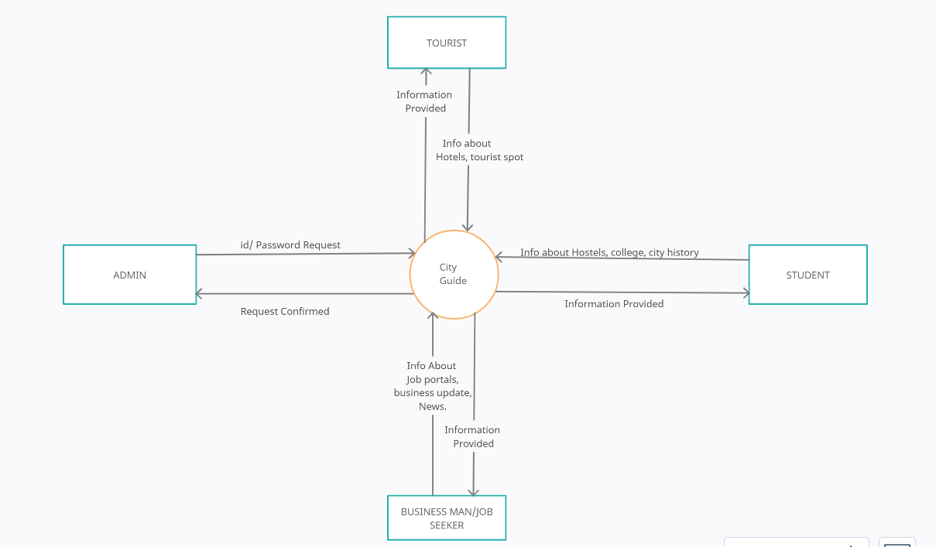

**MODULES:**

* Administrator Module
* Tourist Module
* Jobseeker Module
* Businessman Module
* Student module

**MODULES DESCRIPTION:**

**Administrator Module:**

The admin module is the major module as it is responsible for carrying out the major operations regarding site updates, business updates; job alerts etc., It maintains information regarding other modules which are present in the system. The various software components in administrator module are update alerts, update industries, update hotels, view resumes, and update site information.

The details entered by admin are Complete city history such as social, Business details such as top companies in the city and its information, Job details such as vacancies and companies profile, Emergency such as phone numbers of with respect to emergency, Conventional places such as description, location, address and image of the place, regarding news, papers, city channels such which papers are available in the city, Students details such as colleges, institutions, hostels, libraries……, Tourist details such as tourism places, hotels, maps, cheap bookings. The details entered by admin can also edit the details once he entered.

**Tourist Module:**

Tourist module is maintaining the information regarding the city tourist spot, hotels in the city entertainment in this city etc.., the user after registration as a tourist is considered as authorized user. The various software components in the tourist module are view theaters, view hotels, view city map, view ATM locations, view hospitals, view city history, etc.

**Jobseeker Module:**

Jobseeker module is the commercial module as it needs some paid services. The Jobseeker views the jobs portal and finds a job availability. He then posts his resume to administrator. The various software components available in the jobseeker module are view jobs, view city information, view institutes, view city updates, post resume, view alerts, view city location.

**Businessman Module:**

Businessman module consists of information regarding various business in the city, industries in the city, with social and political influence of the city.

The various software components in the businessman module are view city history, view markets, view alerts, view industries, view hotels, view labor, view hotels, view labor, view jobs.

**Student Module:**

The student module maintains the various information regarding various institutes in the city. The various software components are view library, view books, view institutes, view engineering colleges, view coaching centers, view journals.

**SYSTEM REQUIREMENTS:**

**HARDWARE REQUIREMENTS:**

* System : Pentium i3 Processor
* Hard Disk : 500 GB.
* Monitor : 15’’ LED
* Input Devices : Keyboard, Mouse
* Ram : 4 GB

**SOFTWARE REQUIREMENTS:**

* Operating system : Windows 10/11.
* Coding Language : JAVA.
* Frontend : JSP, HTML, CSS, JavaScript.
* IDE Tool : Netbeans IDE 8.2.
* Database : MYSQL.